S.G.K Govt Degree college Vinukonda





1. Nam : THOTA NARASIMHA RAO 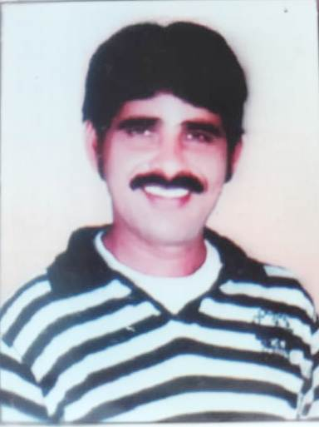
2. DESIGNATION : LECTURER INPOLITICAL SCIENCE
3. Date of Birth : 05-04-1979
4. Email :[thotanarasimharao123@gmail.com](mailto:thotanarasimharao123@gmail.com)

5. PHONE : 8185898181

6. QUALIFICATION : M.A

1. Total Experience : 4 Years
2. Research Projects :NIL
3. Publications :NIL
4. Papers Presented in Seminars/conferences : NIL
5. Address : **T.NARASIMHA RAO**

**Guest Lecturer in POLITICAL SCIENCE**

**S.G.K Govt Degree College**

**Vinukonda**

**Guntur District**